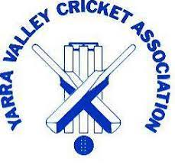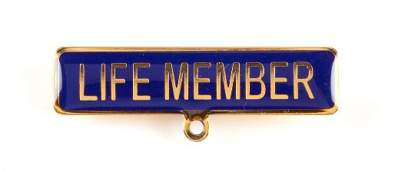

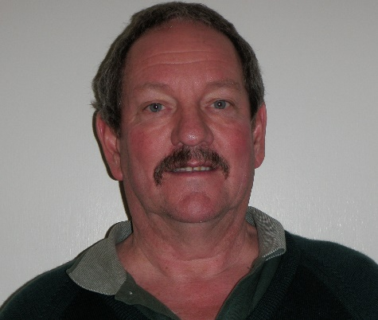
G.A.C. (Greg) Mitchell A.S.M. 2014
Yarra Junction Cricket Club

Greg was born in 1952 at Box Hill Hospital but has lived in the Yarra Junction area since being taken home from hospital after his birth. His Grandfather and Father were bakers in Yarra Junction and Greg went on to work for the NAB Bank for five years and then the State Government for forty five years until retirement.
Greg played all his cricket at Yarra Junction, following in the footsteps of his father who played at the club for many years. Greg is described as being a good opening batsman and leg spin bowler who was also the wicketkeeper for the First Eleven for five years. His leg spin bowling led to three club bowling averages to go with eleven club batting awards and Greg was club champion on three occasions.
Greg served the club as Captain/Coach, played over 500 games until retirement as a player in 2014 and has had over fifty years continuous service on the club committee. He currently serves as the club Treasurer and was club Secretary for a remarkable forty years. Greg played or coached in seven premierships and coached the Yarra Junction juniors for over twenty years. Greg was rewarded with Life Membership of the Yarra Junction Cricket Club in 1983 and received the Australian Sports Medal in the year 2000.
Besides an imposing record at club level, Greg provided sterling service to the Yarra Valley Cricket Association. Greg represented the Association in Country Week cricket, was an Association selector for two years and won junior and senior batting and bowling awards. On the administrative side Greg served as Senior Vice President for 12 seasons, Registration Secretary for six years, Junior Vice President for one year and on the general Committee for four years.
Greg was deservedly awarded Life Membership of the Yarra Valley Cricket Association in 2014. He was also awarded the Victorian Country Cricket League ‘Bob Merriman Service Medal’ in 2020. This medal recognises meritorious contributions to the conduct of VCCL programs and competitions.

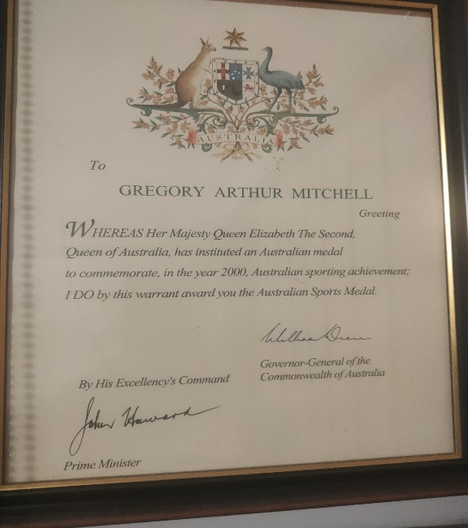

At the RDCA Senior Presentation Night held on 21st April; 2023, Greg was inducted into the RDCA Hall of Fame, a very appropriate recognition of his many years of service to the Yarra Valley Cricket Association, the RDCA and Yarra Junction Cricket Club.
In the Hall of Fame Program distributed on the night, the following words about Greg were included:
“Greg played all his cricket at Yarra Junction C.C. as a wicketkeeper. Spin bowler and opening batsman. Many years were spent in the first eleven with total club games exceeding 500. Greg won three club bowling averages, eleven club batting awards and was club champion on three occasions. Greg served the club as Captain-Coach for many years before retiring as a player in 2014. He played in seven premierships and was club junior coach for over twenty years. Club Life membership in 1983 was rich reward for Greg’s service which continues an incredible forty years later. Greg has now served on the club’s Committee for over fifty consecutive years in various roles. At Association level Greg has won batting and bowling awards and been a Country Week representative. He has served as Senior Vice President (12 years), Junior Vice President (1 year), Registration Secretary (6 seasons), and on the general committee for 4 years. Greg received the Australian Sports Medal in 2000 and was awarded the VCCL Bob Merriman Medal (meritorious contribution to VCCL programs and competitions representing the YVCA) in 2020. “
….. 2
….2

Greg (L) receives his RDCA Hall f Fame award from Association President Michael Finn on 21st April 2023.
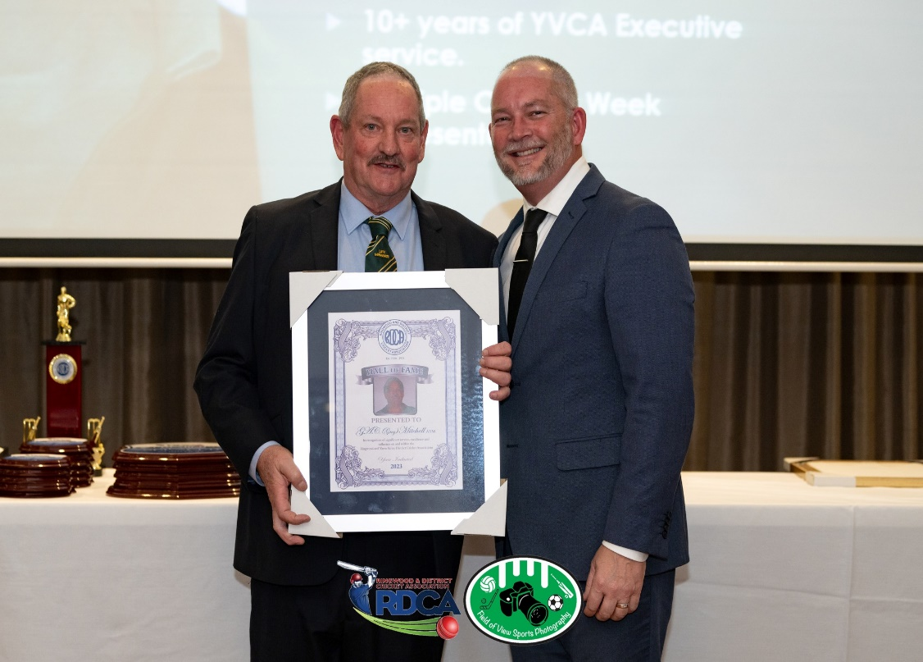
Field of View Photography

ID 5/2023

