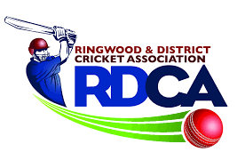

Ringwood and District Cricket Association
_{A116}
Founded 1920
Affiliated with the V.M.C.U.

JUNIOR PERMIT FORM

Date:

Club:

Player:

Has played matches in grade

Requests to play in grade in round

Reason:

Email to Mandy Dolman dolman7@bigpond.com

© 2018 RDCA. All Rights Reserved. Version 1.0 Season 2018/2019

