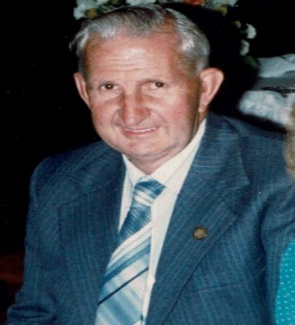
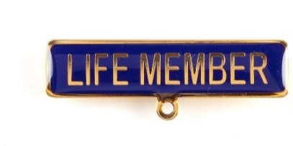
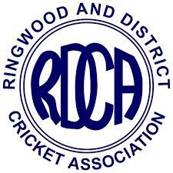
A.R. (Bob) Bisset - 1953/1954
Bob's father began a timber, hardware and grain store opposite the Coach and Horses Hotel in Ringwood with the store later becoming an ice-skating rink in the late 1960s.
Bob Bisset's name first appeared in the Association's records on the Ringwood Cricket Club's registered playing list for the 1927/28 season. He was later to become Ringwood's delegate to the Association in 1941/42, 1945/46 and 1946/47.
Bob Bisset was to go on and provide tremendous service to the Association in a number of positions and over many, many years. Besides being an umpire for some time, Bob was Secretary of the Association for 2 seasons in 1946/47 and 1947/48 and served as Treasurer for the period 1937/38 until 1991/92, an extraordinary term of voluntary service. Add to this some time as a Vice President and as a Team Manager for representative teams and it is easy to see why Bob Bisset was awarded Life Membership of the Association at the Annual General Meeting held on 28th August 1953. The fact that the majority of his service occurred after being awarded this honour shows his dedication to the Association. He was also the Association's delegate to the then Victorian Junior Cricket Association (VJCA) from 1955/56 until 1964/65.
The following tribute, compiled by Bill Wilkins and Lindsay Trollope, appeared in the 1990/91 Association Annual Report:
At the Annual Meeting, Bob Bisset will conclude an amazing 50 years as Treasurer of the Association. It is difficult to comprehend that a person could hold such an office for half a century, but indeed Bob has done that with good humour and patience for all that period. The majority of us were not even born when Bob began his service as Treasurer. Bob has been greatly assisted by his wife Fay and I adequately thank these people. A special function will be conducted later in the year. Bob's expertise and his persistence will be greatly missed.
As further recognition of Bob's administrative service, the Association's 'Best Administered Club' trophy is named after Bob Bisset.
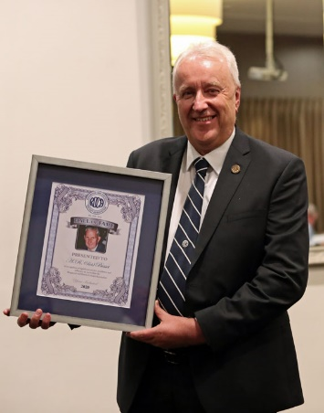
Bob was inducted into the RDCA Hall of Fame at the RDCA Centenary and Hall of Fame dinner held in March 2021.
The following words about Bob were included in the RDCA Centenary and Hall of Fame program for the dinner held on 26th March 2021
“A stalwart of the Ringwood C.C. from the late 1920s and serving the RDCA until 1991-92, including over 50 years as Treasurer and two years as Secretary. After finishing as a player Bob became an umpire before serving in a number of Association positions including as Treasurer, Secretary, Vice President, delegate to the Victorian Junior Cricket Association and as a Team Manager for representative teams. Awarded Association Life Membership in 1953-54 thus the majority of his service was after this honour. The senior Best Administered Club award is named in his honour.”
Bob’s son Phil proudly collects the RDCA Hall of Fame award at the RDCA Centenary and Hall of Fame Dinner held on 26th March 2021.
Hall of Fame Induction

…………..2
….2

At the RDCA Senior Presentation Night held on 21st April 2023, Bob was elevated to Legend Status within the RDCA Hall of Fame. This richly deserved award provides further testament to Bob’s significan t contribution to the Ringwood and District Cricket Association.
On hand to receive the recognition of Bob’s elevation to Legend status were Bob’s very pleased and proud children.

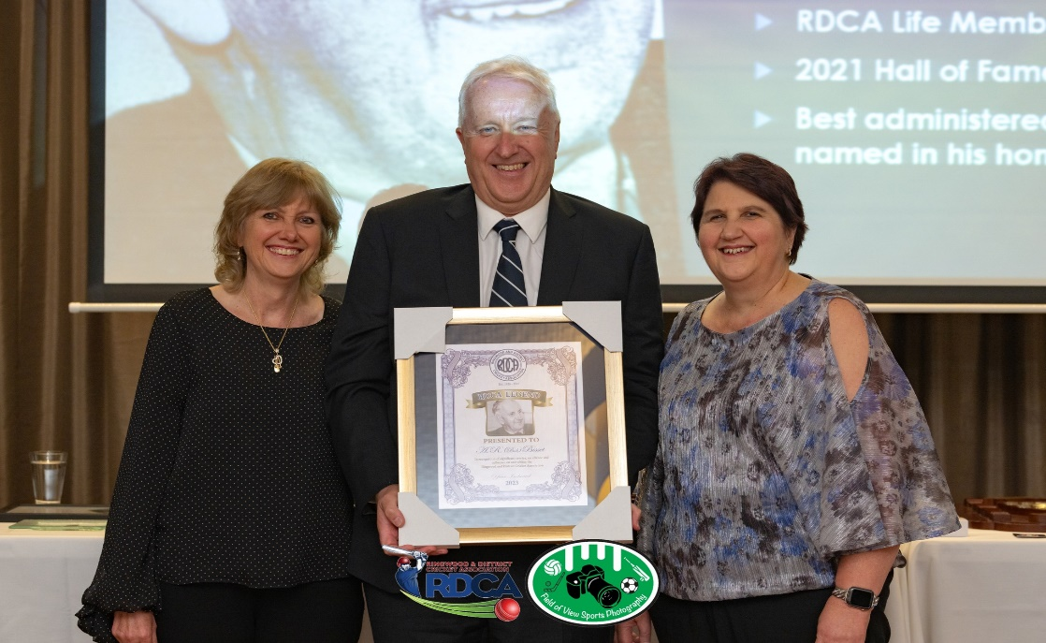

Photos by Field of View Photography

ID 5/2023

