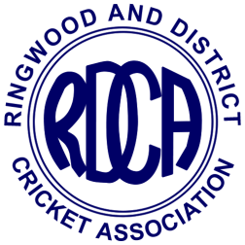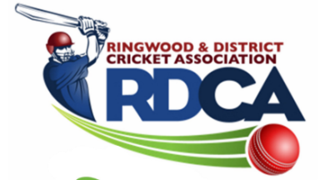

RINGWOOD AND DISTRICT CRICKET ASSOCIATION INC. (A116X)

CRICKET BALL ORDER FORM 2019/20 SEASON
Submit to Ian Spencer: Email - spencer@rdca.com or “balls@rdca.com” or Fax - 9876 7206
• Balls to be ordered in multiples of 12
• Orders will be taken in last week of August, first week of October, last week of November and second week of January.
ORDER DATE: ____/____/20____
CLUB NAME: _______________________________ PERSON ORDERING: _________________________________

BRAND OF BALL | BALL PRICE | QUANTITY ORDERED  (MULTIPLES OF 12) | TOTAL
TUF PITCH (156g) | $45.25
RED KING (156g) | $37.00
KOOKA COLT (156g) RED | $30.00
KOOKA COLT (142g) RED | $30.00
KOOKA COLT (142g) PINK | $34.00
KOOKA SPECIAL TEST  WHITE (156gm) | $46.50

$

TOTAL AMOUNT PAYABLE

Note:
• Payment must be made at time of collection (cheque) or be prepaid by EFT.
• Discount of 3% will be paid to clubs in due course when balls are collected and paid for within 7 days of contact person(s) being notified that they are available.
• Club will incur a fine of 5% of total payable if balls are not paid for within 14 days of being notified they are
available.

