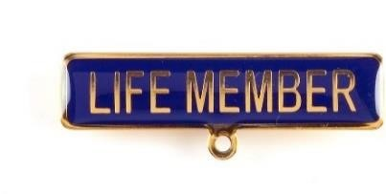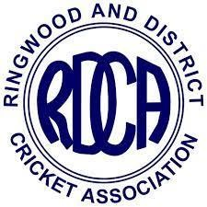

P. T. (Pat) Meehan - 2004/2005

Pat's cricket career started at Burwood Socials Cricket Club at age 15 and he represented the Burwood District Cricket Association (now part of Box Hill Reporter District Cricket Association) at Under 21 level. He moved to Burwood Cricket Club in the Eastern Suburban Association (now ECA) where he played in 3 premierships in his 5 years at the club. Kew Cricket Club in the Sub District competition followed and he played in a premiership team in his 3 years at that club. Premiership success continued at Donvale Cricket Club where he played for 3 years before retirement from playing due to his wife’s ill health.

After a break of some 11 years Pat came out of retirement to play for Templeton Cricket Club from 1983 to 1988. In 5 seasons he played in 2 premierships with the First and Second Elevens and spent 4 years on the Committee, including 2 as Vice President and Junior Co-ordinator.

After a second retirement from playing, Pat was talked into umpiring in 1989 by the late Ken Dunham, also an RDCA Life Member. He umpired for 10 seasons during which he officiated in every Chandler Shield Grand Final for the last 8 of those years. Whilst umpiring he was the Assistant Secretary of the RDCA Umpire's Association for a year and then Secretary for 8 years. Pat became a member of the Association Executive in 1990, initially as the Umpire's Association representative, and then continued on the Executive until it was re-structured in 2003. From then he served as a member and then Chairman of the Senior Operations Committee that has since become the Senior Committee. At the time of writing Pat is still in that position.
Since the year 2000 Pat has also acted as the Association's delegate to the former Outer East Regional Cricket Council and to the Victorian Metropolitan Cricket Union (VMCU) where, besides being a Director, he is a member of the Junior Carnival Match Sub Committee as the Umpire's Co-ordinator (21 years to date). Pat has served on the RDCA
Tribunal and was Chairman of the former Investigation Committee for several years.

Pat was awarded Life Membership of the Association at the 2004 Annual General Meeting and he was awarded Life Membership of the RDCA Umpires Association in2018. Pat has a senior premier grade competition named in his honour.

In March 2021 Pat was inducted into the inaugural RDCA Hall of Fame.

The following words about Pat were included in the RDCA Centenary and Hall of Fame program for the dinner held on 26th March 2121:

“Pat’s connection with the RDCA started at Templeton C.C. in 1983 where he would earn cap #15, serve on the club committee and become a dual premiership player. Ten years as an umpire, including 8 years standing in top grade Grand Finals lead to Pat joining the Umpire’s Association Executive and he became that Association’s representative on the main RDCA Executive in 1990.
Pat has served for many years on the Senior Operations Committee/ Senior Committee to date, including over 10 years as Chairman, as the Senior Representative and Under 21 co-ordinator and the Association’s representative and Delegate on various IACC/COUV/VMCU/Outer East committees. Pat has a senior Premier Grade competition named after him and is a Life Member of the RDCA and the Umpire’s Association.”

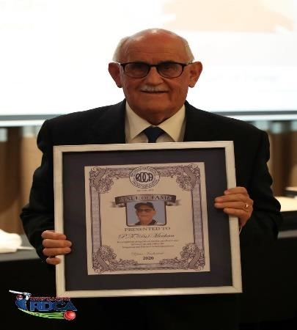
Field of View Photography

Pat’s service to the RDCA has continued with a strong involvement in organising the RDCA and Yarra Valley Cricket Association merger and the bringing of the Women’s East cricket competition to the RDCA umbrella.

At the RDCA Senior Presentation Night held on 21st April 2023 Pat was elevated to Legend Status within the RDCA Hall of Fame, further recognition of Pat’s significant contribution to the RDCA over many years.

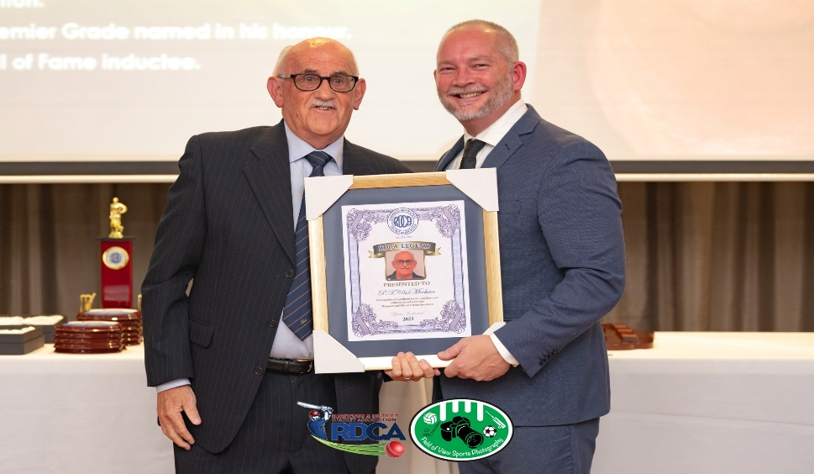

Field of View Photography

ID 5/2023

