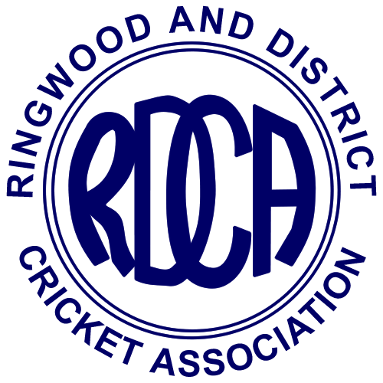 | JUNIOR SECTION  Postal Address:  Lot 2, 56 Summit Road,  Lilydale, 3140  Email Address:  dolman7@bigpond.com  Web Site:  www.rdca.com  Founded 1920  Affiliated with the VMCU  Incorporation Number A116x

RDCA Representative Consent Form

Club: |  | Season:

Surname: |  | First Name:
Date of Birth:

Address:
Suburb: |  | Post Code:

Phone: |  | Mobile:

Email:

Prior & Current Major Illness / Injuries / Medical Conditions / Allergies & Medication Requirements:
I acknowledge that the Representative Carnival is run during the first half of January each year and by making myself available for selection, I accept the responsibility of being available for all the carnival and lead up period.

I consent to participating in the RDCA Representative Program and Competitions. I acknowledge that cricket can be inherently dangerous and that serious accidents can happen, which may result in my child being injured.

Except to the extent that the Trade Practices Act 1974 (Cth) or other legislation applies, and cannot by contract be excluded, I agree that it is a term of my participation that the RDCA is absolved and indemnified from all liability however arising from injury or damage however caused arising out of my participation in the Representative Program and Competitions or in any way due to any negligent act, breach of duty, default and/or omission on the part of Ringwood and District Cricket Association Inc.

I agree to release and forever discharge the RDCA from all claims (except those claims made and accepted under a relevant RDCA insurance policy, to the extent of the cover provided under the policy – summary available upon request) that I may have or may have had but for this release arising from or in connection with my participation in the RDCA Representative Program and Competitions.

I authorise RDCA representatives to arrange medical or hospital treatment (including ambulance transportation) if I am not available to do so and I indemnify the RDCA of all costs associated therewith.

Privacy Statement: the RDCA is committed to the protection of your personal information. Any personal information you provide to the RDCA will be used for those purposes, which the information was gathered for as stated and related purposes which can be reasonably expected.

I have read, understood, acknowledge and agree to the above declaration including the warning, release and indemnity.

Parent/Guardian Name:
Signature:
Date:

