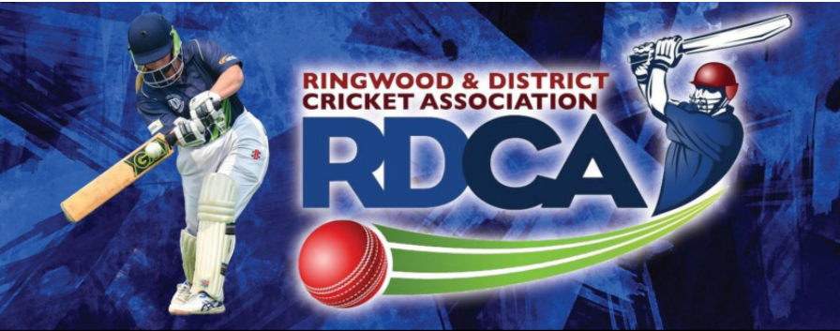
DIRECT SUPPLY OF BALLS – INSTRUCTIONS TO CLUBS
Clubs must purchase ALL match balls from the Association. Failure to do so will incur a fine. RDCA approved balls must be used in all Junior, Senior, Veteran and Women’s matches including one-day, two-day and T20.
Ball orders
- Clubs are to provide Ian Spencer (rdca@sme.com.au) with the name or names of person(s) who are authorised to order balls on behalf of their club.
- Clubs will have four opportunities to order stock. They being, second week of August, first week of October, last week of November and second week of January.
- Balls must be ordered in multiples of 12 per brand.
(The initial delivery of balls should be available about 10 days prior to season starting)
- Clubs will be reminded of the window in which an order can be submitted.
- Clubs should be mindful that balls will not be released without first being paid for and the full order must be taken.
- An order form is available from Downloads section of the website. It has columns for quantity required, the prices are printed thereon and person ordering is to calculate total amount payable.
- Orders are to be sent by email to rdca@sme.com.au
Order payment
- A Club will receive a 3% discount when balls are paid for within 7 days of being informed that they are available.
- Payment can only be made via EFT (preferred) or by club cheque (made payable to RDCA).
- If your club is paying by EFT, a copy of the receipt is to be provided to Ian Spencer at least a day ahead of when club person intends to collect the balls.
- NOTE! Cash payment will not be accepted for ball purchases from the RDCA.
- A club will be fined 5% of order value if the balls are not paid for within 14 days of being informed that they are available.
- Account details for EFT payment are as follows:
Bank – East Ringwood Community (Bendigo) Bank
BSB – 633-000
Account number – 146536172
Account name – RDCA Cricket Ball account
Ball collection
- Clubs will be informed when balls are available for collection.
- The full value of order is to be paid, prior to or upon collection and any discount applicable, or late collection fine, will be “Credited”, or “Debited”, in due course and appear on the Club statement issued monthly by the RDCA Finance Manager.
- Balls can be collected from Saxon Sports Indoor Centre (51 Lusher Rd Croydon) between 2.00pm and 8.00pm Monday-Friday or, if those times are not suitable, by appointment with Paul Attfield (0402 133 441) or Scott Brasher (0409 700 250)
- Obviously, clubs may use “RDCA approved balls” left over from last season.
- “Practice balls” can be acquired from the retail outlet that your club normally deals with.

NOTE

Saxon Sports is a collection point only in this exercise.

Ian Spencer

