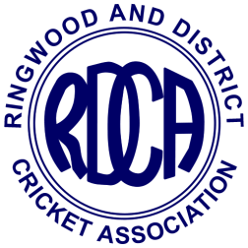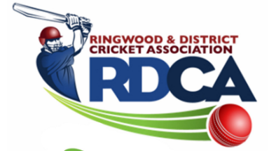

RINGWOOD AND DISTRICT CRICKET ASSOCIATION INC. (A0110509M)

CRICKET BALL ORDER FORM 2020/21 SEASON
Submit to Ian Spencer: Email – “rdca@sme.com.au”
- Balls to be ordered in multiples of 12
- Orders will be taken in last week of September, third week of November and second week of January.
ORDER DATE: ____/____/20____
CLUB NAME: _______________________________ PERSON ORDERING: _________________________________

BRAND OF BALL | BALL PRICE | QUANTITY ORDERED  (MULTIPLES OF 12) | TOTAL
TUF PITCH (156g) | $46.75
RED KING (156g) | $38.00
KOOKA COLT (156g) RED | $31.00
KOOKA COLT (142g) RED | $31.00
KOOKA COLT (142g) PINK | $35.00
KOOKA SPECIAL TEST  WHITE (156gm) | $48.00
STAR BALL  For Mini Bash and lower levels of girls competitions  (in multiples of 6) | $12.00

TOTAL AMOUNT PAYABLE
BALLS RECEIVED (signature) ______________________________________(DATE)___________
Note:
- Payment must be made at time of collection (cheque) or be prepaid by EFT.
- Discount of 3% will be paid to clubs in due course when balls are collected and paid for within 7 days of contact person(s) being notified that they are available.
- Club will incur a fine of 5% of total payable if balls are not paid for within 14 days of being notified that they are available.

