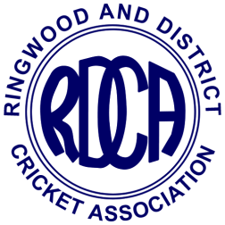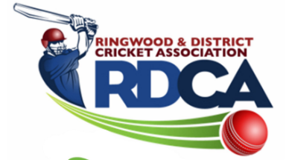

RINGWOOD AND DISTRICT CRICKET ASSOCIATION INC. (A0110509M)

CRICKET BALL ORDER FORM 2023/24 SEASON
Submit to Ian Spencer: Email – “rdca@sme.com.au”
- Balls to be ordered in multiples of 12 (dozens)
- Orders will be taken in the second week of August, first week of October, last week of November and second week of January.
ORDER DATE:
CLUB NAME: PERSON ORDERING:

BRAND OF BALL | BALL PRICE per DOZEN | BOXES ORDERED  (BOXES OF 12) | TOTAL  (BOXES x PRICE)
TUF PITCH (156g) RED | $618.00
RED KING (156g) RED | $510.00
KOOKA COLT (156g) RED | $426.00
KOOKA COLT (142g) RED | $426.00
KOOKA COLT (142g) PINK | $474.00
SPECIAL TEST (156gm) WHITE | $642.00
SPECIAL TEST (142gm) WHITE (Women’s competition) | $642.00
RED KING (142gm) WHITE  (Women’s competition) | $534.00
STAR SOFTABALL WHITE  (For Mini Bash and  lower levels of girls competitions) | $144.00

TOTAL AMOUNT PAYABLE

Notes:
- Payment must be made at time of collection by prepaid EFT (preferred) or cheque.
- Discount of 3% will be paid to clubs in due course when balls are collected and paid for within 7 days of contact person(s) being notified that they are available.
- Club will incur a fine of 5% of total payable if balls are not paid for within 14 days of being notified they are available.

